ALPINE FIRE PROTECTION DISTRICT

Procedures for monthly fire extinguishers inspection

Did you know that it is required for every hand portable fire extinguisher to be inspected every month and signed off?

NFPA 10 Standard for Portable Fire Extinguishers 2021 Edition
Chapter 7 Inspection, Maintenance, and Recharging of Portable Fire Extinguishers
7.1.1 - Responsibility – The owner or designated agent or occupant in which fire extinguisher are located shall be responsible for inspection, maintenance and recharging.
7.1.2.3. – Persons performing 30-day inspections shall not be required to be certified.
7.2.1. - Frequency – Shall be inspected manually when initially placed in service.
7.2.1.1. – Fire Extinguishers and Class D extinguishing agents shall be inspected either manually or by means of an electronic monitoring device/system at intervals not exceeding 31-days.

What should I be inspecting and how do I maintain a logbook?
As per NFPA 10 2021 Edition Section 7.2.2. When performing the monthly inspections on portable fire extinguishers see the instructions below and follow the chart example at the end of this letter.

Procedures in inspection of hand portable fire extinguishers as per California Fire Code 2022
- Location in designated place

- Visibility of the extinguisher or means of indicating the extinguisher location

- Access to the extinguisher

- Pressure gauge reading or indicator in the operable range or position

- Fullness determined by weighing or hefting

- Condition of tires, wheels, carriage, hose, and nozzle for wheeled extinguishers

- Indicator for non-rechargeable extinguishers using push-to-test pressure indicators

7.2.4.1.1 - Where manual inspections are conducted, records for manual inspections shall be kept on a tag or label attached to the fire extinguisher, on an inspection checklist maintained on file, or by an electronic method.
7.2.4.1.2 Where manual inspections are conducted, the month and year the manual inspection was performed and the initials of the person performing the inspection shall be recorded.
7.2.4.1.4 Personnel making manual inspections shall keep records of all fire extinguishers inspected, including those found to require corrective action.

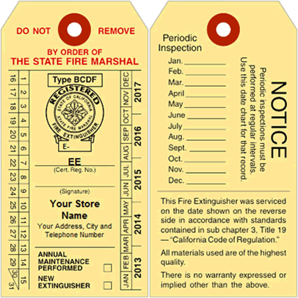
Your service company will fill out the front of the service tag and you the customer are responsible for the back!

